**SECTION 6**

**SCREENSHOTS**

**Program :**

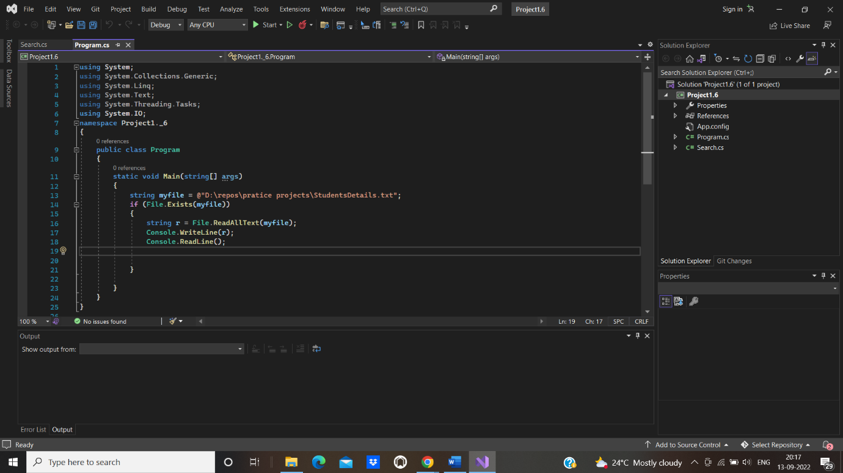

**Output :**

